Q1.1.Design a class which represents a student. Every student record is made up of the followingfields.i)Registration number(int)ii)Full Name(String)iii)Date of joining (Gregoriancalendar)iv)Semester(short)v)GPA(float)vi)CGPA(float)Whenever a student joins he will be given a new registration number. Registration number is calculated as follows. If year of joining is 2012 and he is the 80thstudent to join then his registration number will be 1280.Write member functions to do the following.a)Provide default and parameterized constructors to thisclassb)Write display method which displays the record. Test the class by writing suitable mainmethod.c)Create an array of student record to store minimum of 5 records in it. Input the records and displaythem

import java.util.* ;
class Student{
int reg ;
String name ;
short sem ;
float gpa ;
float cgpa ;
Date date ;
static int counter = 0 ;
public Student(){
counter++ ;
reg = 0 ;
name = "" ;
sem = 0 ;
gpa = 0.0f ;
cgpa = 0.0f ;
GregorianCalendar gc = new GregorianCalendar();
this.date = gc.getTime() ;
int year = date.getYear();
System.out.println(year+1900) ;

}
public Student(String fullname, short semester, float gpa , float cgpa ){
counter++ ;
sem = semester ;
name = fullname ;
this.gpa = gpa ;
this.cgpa = cgpa ;
GregorianCalendar gc = new GregorianCalendar();
this.date = gc.getTime() ;
this.reg = ((date.getYear() +1900)%100)*100 + counter ;

}

void display(){
System.out.println("Details of the student are") ;
System.out.println("Name :"+name+"\t gpa:"+gpa+"\tcgpa"+cgpa+"\t Date of joining:"+date+"\treg_no:"+reg);
}
}
public class Studentdemo{
public static void main(String[] args){
Student[] stu = new Student[5] ;
Scanner sc = new Scanner(System.in);
float gp,cg ;
short se ;
String name = "" ;
for(int i = 0 ; i<5 ; i++){
System.out.println("enter name");
name = sc.nextLine();
System.out.println("enter gpa");
gp= sc.nextFloat();
System.out.println("enter cgpa");
cg = sc.nextFloat();
System.out.println("enter semester");
se = sc.nextShort();
stu[i] = new Student(name,se,gp,cg);
sc.nextLine();
}
for(int i = 0 ; i<5 ; i++){
stu[i].display();
System.out.println();
}
}
}

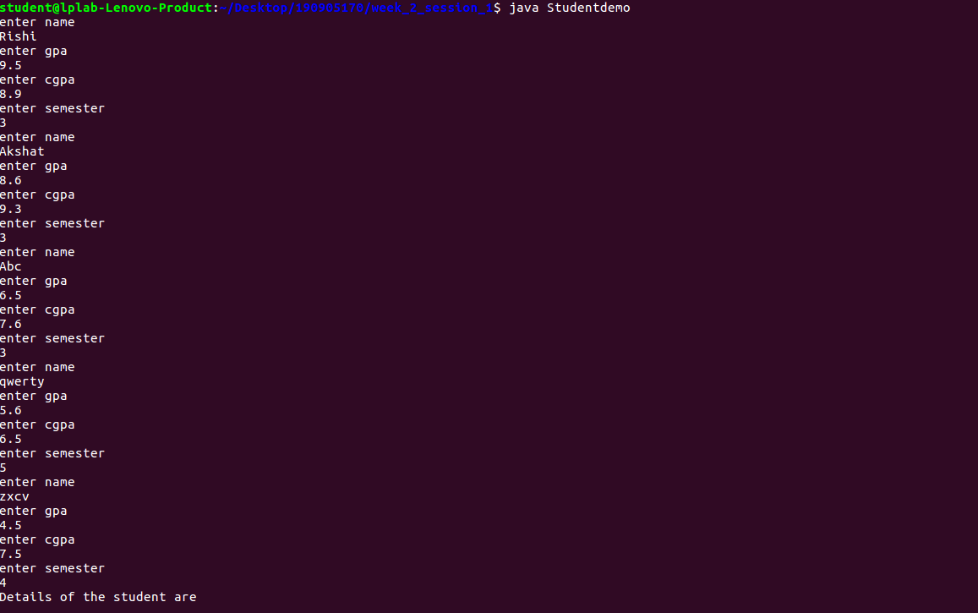
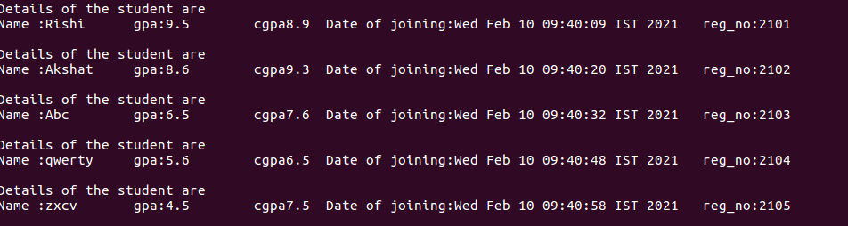

Q2 (Lab7).Design an interface called Series with the followingmethodsa.Get Next (returns the next number inseries)b.reset(to restart theseries)c.set Start (to set the value from which the series shouldstart)Design a class named By Twos that will implement the methods of the interface Series such that it generates a series of numbers, each two greater than the previous one. Also design a class which will include the main method for referencing the interface

import java.util.* ;
interface Series {
int getnext() ;
void reset() ;
void setstart(int x) ;

}
class ByTwos implements Series {
int start ;
int current ;
public ByTwos(){
start = 0 ;
current = 0;
}
public int getnext(){
current+=2 ;
return current ;
}
public void reset(){
current = start ;

}
public void setstart(int x){
current = x ;
start = x ;
}
}

public class Seriesdemo {
public static void main(String[] args){
ByTwos bt = new ByTwos();
for(int i =0 ; i<3 ; i++)
System.out.println("next is " +bt.getnext()) ;
ByTwos bt1 = new ByTwos() ;
bt1.setstart(15);
for(int i =0 ; i<3 ; i++)
System.out.println("next is " +bt1.getnext()) ;
bt1.reset();
System.out.println("value after reset is "+ bt1.current) ;
}

}
